REPORT
OF
EXCHANGE PROJECT PROGRAM, 2014
Prepared by :
Swati Dey
Word of thanks
First of all I want to thank Child Learn Netherlands for inviting me (Swati Dey), teacher of BWI/INBCWWF/VSK Child Learn school, Bhubaneswar, and Sagarika Barik, teacher of Dumduma school of Bhubaneswar, Odisha state of India to participate Exchange Project Program from 22nd of June until 30th of June, 2014 including Child Learn Marathon held on 29th June,2014 in Schimmert at the Netherlands. I also thank BWI & INBCWWF(Odisha) for giving me such a golden opportunity to visit the Netherlands.
It is a very beautiful country with incredible scenery.
Report of the activities
On 22 June
When we arrived at Schiphol Amsterdam Airport, Roel de Vries welcomed us and took us to his house in IJsselstein. In the evening we went sight-seeing and diner in Utrecht. We stayed overnight at his home.
On 23 June
The very next day, Nanning Schotanus took us to the Hostellerie De Munten at Weert. We had lunch at the house of Nanning en Klazien. Then we went to see the Nature Park Vosseven and we walked for two hours in the evening.
On 24 June
We visited a special school named Herman Broeren school in Roermond. It is the school based on primary and secondary education. Here are children with intellectual disabilities who are pursue their education and the teachers give special care so they will succeed. We discussed with the principal and teachers the many subject about education and saw the entire school. The classrooms are decorated with advance technology and have modern teaching materials with varieties of color and shapes.
The children have a lot of facilities.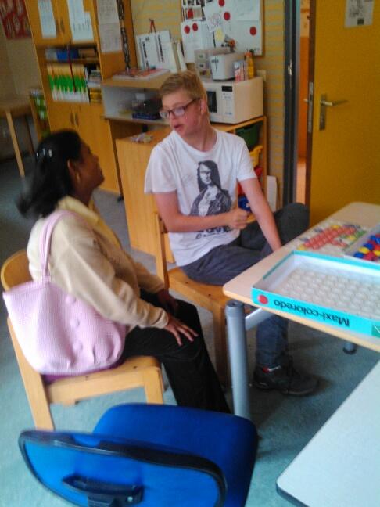
On 25 June
We visited Henry and Christine Okkersen house at Schimmert. Then we visited the public school named “De brede school Kirkeveldsje” and had spoken with the headmistress and teachers. Then we visited all-round the school and asked and answered questions to/from the children. Later we sung with the children. It is a nice school with a library and modern technology. After that we visited the big library of Nuth. It is a beautiful library with different kinds of story books and school books for the children for different age groups.
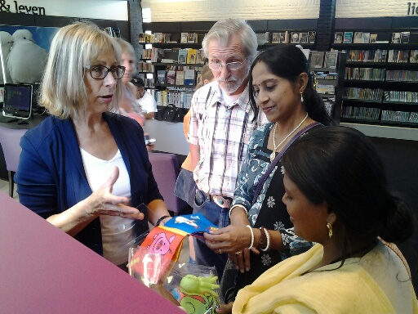
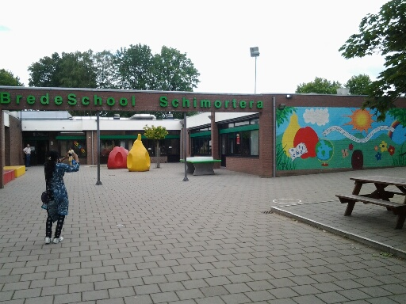

On 26 June
We visited the self-employed construction office with Charles Verhoef. We had tour at his new office and then left to visit the FNV Bouw Office. We presented our project program of India and had conversation with the staff delegation board of FNV Bouw and FNV Mondiaal.
On 27 June
We were invited as special guest to the opening of the City Hall of Weert. We attended the ceremony , had a guided tour at the Mayor Office and meet the Mayor (Jos Heijmans) and are on photos with him.
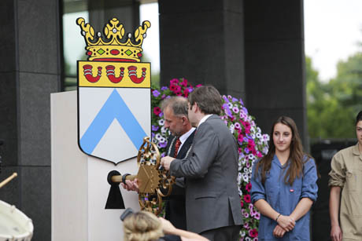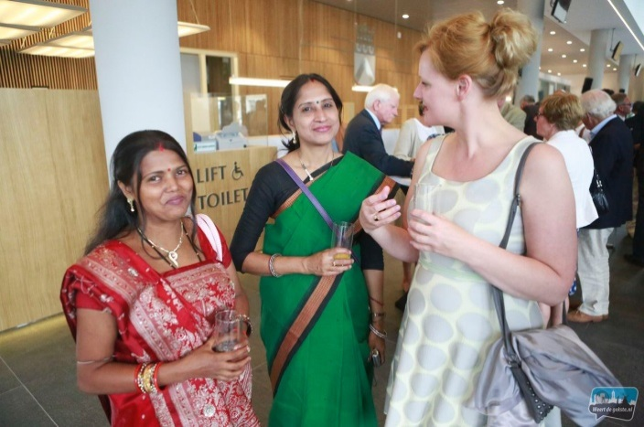

On 28 June
We visited Maastricht. We had boat trip on the canals among the city. The scene of rising and falling of water in the canal and opening and closing of the gate to pass the boat is incredible and strange. We enjoyed the trip.

On 29 June
We went to Schimmert to attend the CL. Marathon 2014. Many people from different countries came and participated in the Marathon. Skype connection was made with Cl.Dumduma school in Odisha. At first the small children ran in the marathon and got prizes. Then the elder people ran different distances and got prizes. We both also took part, completed 7 km and got a medal. We enjoyed it a lot.
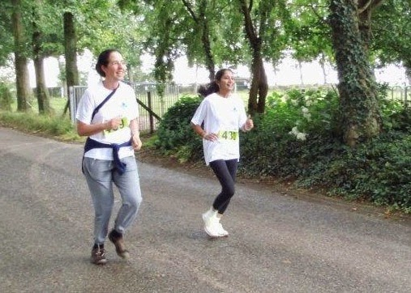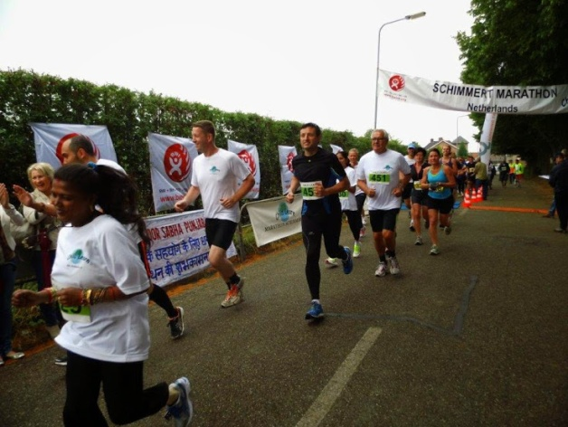
On 30 June
We departed from Schiphol and arrived India at night.
At last I want to thank Roel en Nel de Vries, Nanning en Klazien Schotanus , Henry en Christine Okkersen also Nathalie and Joyce Schotanus for their good hospitality and care. It was for me a memorable experience and priceless moments that I shared with you. And I hope that the things I learned and saw there, I am able to teach the children of our school to some extent.
With this I conclude my report.
Thanking you, also on behalf of Sagarika Barik
Swati Dey.

